Name: Susmita pratihar Enrollment no: 12019002001087 Sec: B Sub: os lab assignment 2 (a)

Source code:

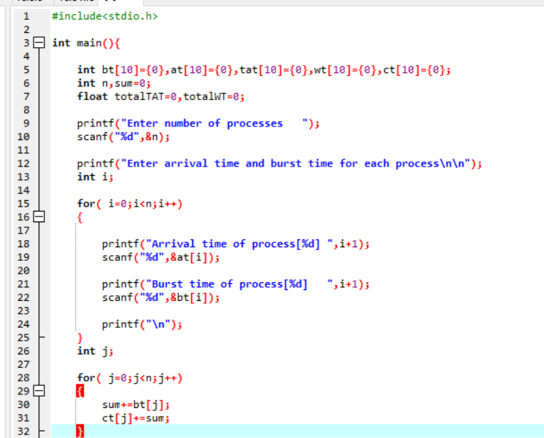

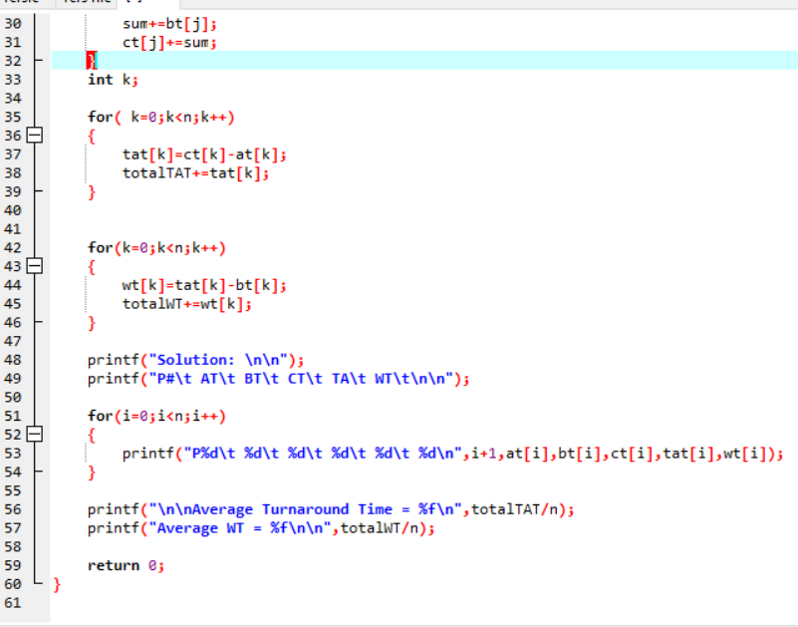

Output:

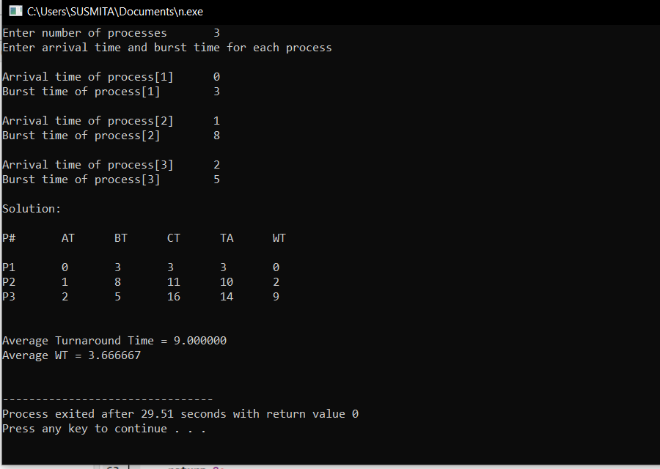

Output:

